# IICT6203 - Database Programming II

## Worksheet 03 – Functions

1. Create a function that returns a table with the total number of people and their total salary for a given department name. Name the function udf_SalaryDepartment.
2. Test the new function with the value ‘Marketing’. Compare your output with the following output:



1. Create a function that returns how many departments are found in a given country. Name the function udf_CountryDepts.
2. Test the new function for the value Germany. Compare your output with the following output:



1. Create a function that accepts a salary and returns the grade level. Name the function udf_GradeLevel.
2. Show the first name, last name, job title, salary and grade level (using the previous function) for all employees. Sort the results by the grade level, and then by the salary. Compare your output with the following output:

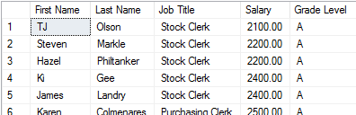

Total Records : 107

1. Create a function that returns Is A Manager if an employee is a manager or Not a Manager if the employee is not. Name the function udf_IsManager.
2. Test the previous functions by showing a list of all the employees and whether they are managers or not. Compare your output with the following output:

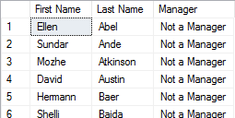

Total Records: 107

1. Show the department name, country name, total employees and total salary per department. Make sure to use the function created in Question 1. Most populated departments should appear first. Compare your output with the following output:

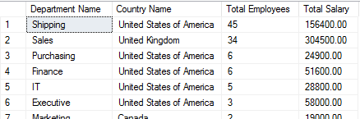

Total Records: 27

1. Modify the previous query to show an aggregate for all departments per country. Compare your output with the following output:

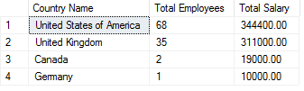

Total Records: 4

1. Show how many managers there are in each country using the function created in Question 7. Compare your output with the following output:

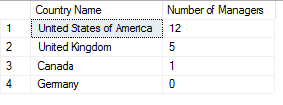

Total Records: 4

***